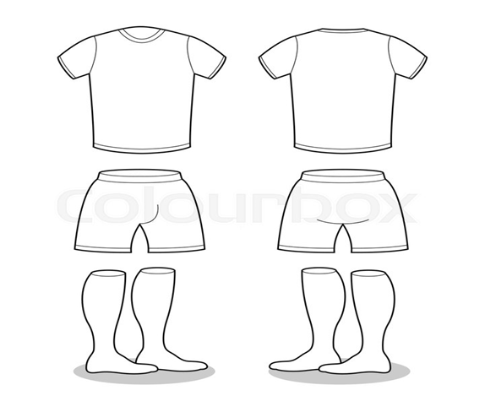
DESIGN US A MATCH KIT
Look at the kits above, can you design the front and back of a match kit for us. We want to see your best colouring and designs. Any colours can be used and why not add a number on it to
Post your attempts on to our Facebook page and check us out more on social media to see all the things we have to offer and help

SOCCER & SPORTING EXCELLLENCE
COACHING ACADEMY

www.twitter.com/soccerexcellenc
www.facebook.com/pages/Soccer-Excellence-Coaching-Academy www.soccerexcellence.co.uk

