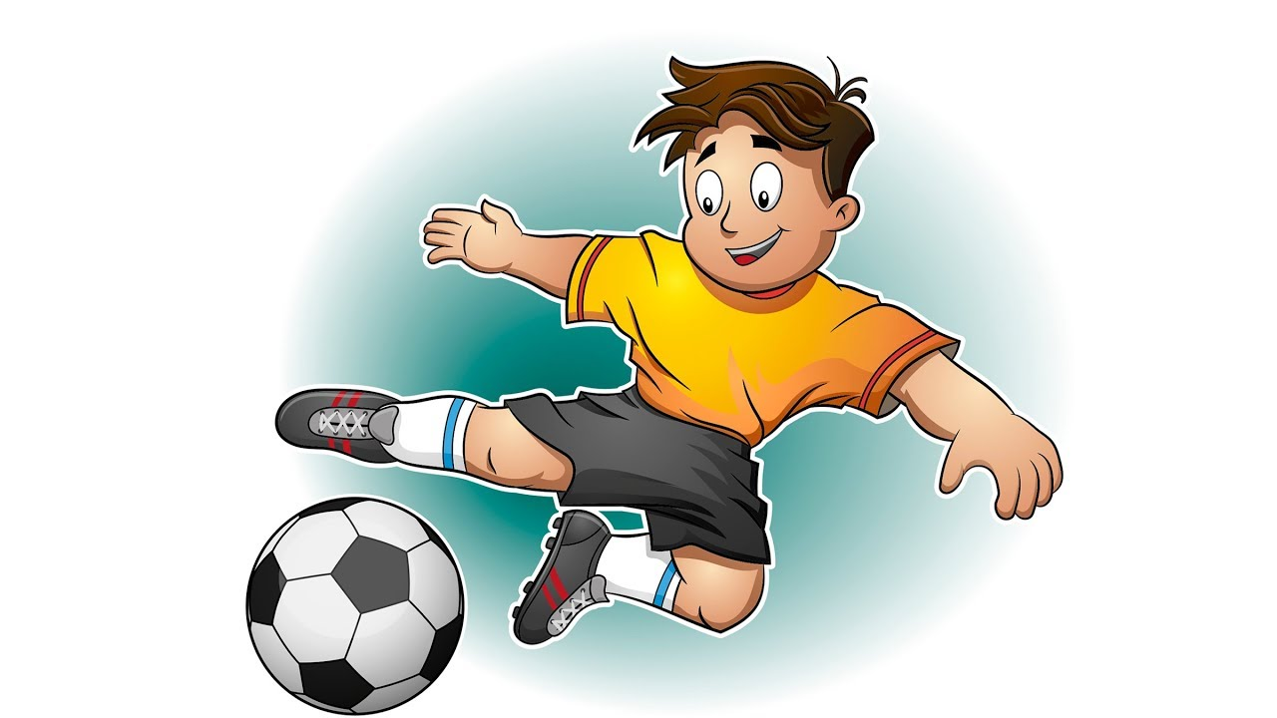

DESIGN YOUR OWN SESSION CHALLENGE!

- Can you complete the example session?
- Can you use the empty template to create your own sessions?
- Can you complete the session that you created?

- Example Session
Sport | Football | Equipment | 1 Football/ 3 Cones/ A wall
Date | 00/00/00 | Time | 00:00
Topic | Dribbling & Passing | Other Info.
Activity 1 [Warm Up]
What does my Activity look like? | How does my session work? | How do I make the activity harder or easier?
 | -Set out 3 cones anywhere in the area.  -Dribble the football between the yellow cones | -Can I do a different turn at each yellow cone?  -Can I dribble to each yellow cone faster?
Activity 2
What does my Activity look like? | How does my session work? | How do I make the activity harder or easier?
Wall | -Pass the ball against the wall  -When the ball bounces back, dribble the ball to the other side and pass again. | -Can I increase how far the pass is?  -Can I pass the ball in the air?
Activity 3
What does my Activity look like? | How does my session work? | How do I make the activity harder or easier?
 | -From one yellow cone, I pass the ball to the next yellow cone.  -From this yellow cone, I dribble to the next yellow cone.  -Then I pass back the cone where I started. | -Can I make a bigger triangle with the cones?  -Can I dribble faster or add in obstacles?

2-My Session
Sport |  | Equipment
Date |  | Time
Topic |  | Other Info.

Can you complete the Session you have designed?

Activity 1 [Warm Up]
What does my Activity look like? | How does my session work? | How do I make the activity harder or easier?
Activity 2
What does my Activity look like? | How does my session work? | How do I make the activity harder or easier?
Activity 3
What does my Activity look like? | How does my session work? | How do I make the activity harder or easier?

